Project Design Phase Solution Architecture

Date | 13 July 2026
Team ID
Project Name | DarshanEase
Maximum Marks | 4 Marks

Solution Architecture:
Solution architecture is a complex process – with many sub-processes – that bridges the gap between business problems and technology solutions. Its goals are to:

- Find the best tech solution to solve existing business problems.
- Describe the structure, characteristics, behavior, and other aspects of the software to project stakeholders.
- Define features, development phases, and solution requirements.
- Provide specifications according to which the solution is defined, managed, and delivered.

Example - Solution Architecture Diagram:

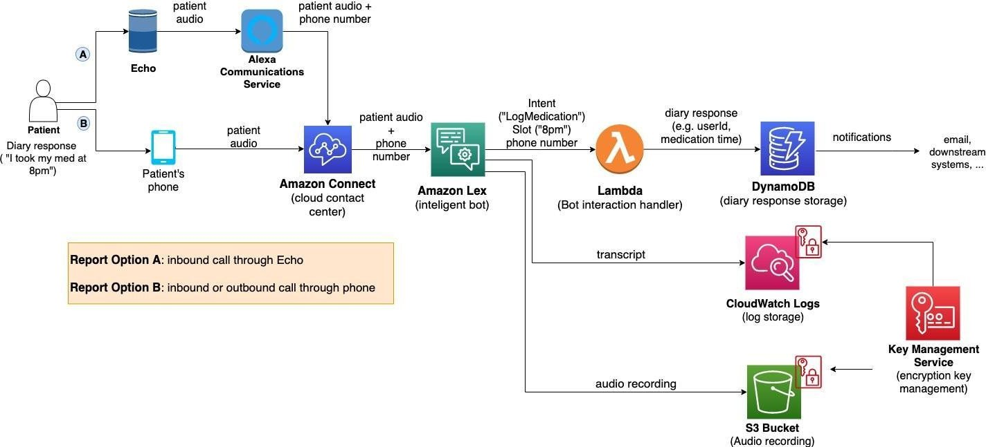
Figure 1: Architecture and data flow of the voice patient diary sample application
Reference: https://aws.amazon.com/blogs/industries/voice-applications-in-clinical-research-powered-by-ai-on-aws-part-1-architecture-and-design-considerations/

Solution Architecture (DarshanEase)
The DarshanEase platform follows a three-tier architecture that separates the system into presentation, application, and data layers. This architecture ensures scalability, security, and efficient management of temple booking operations.

Presentation Layer (Frontend)
The presentation layer represents the user interface through which devotees and temple organizers interact with the system.

Components
  - Devotee Web Portal
  - Temple Organizer Dashboard
  - Admin Panel

Technologies Used
  - React.js
  - Tailwind CSS
  - HTML, CSS, JavaScript
Users can browse temples, book Darshan slots, make donations, and view temple details through this interface.

Application Layer (Backend Services)
The application layer contains the business logic responsible for processing user requests and managing system operations.

Key Services
  - User Authentication Service
  - Temple Management Service
  - Darshan Slot Booking Service
  - Donation and Payment Processing Service
  - Admin Monitoring Service

Technologies Used
  - Node.js
  - Express.js
  - REST APIs
  - JWT Authentication
The backend handles request processing, slot availability checks, secure authentication, and communication with the database.

Data Layer (Database)
The data layer stores all application data including users, temples, bookings, and donation records.

Database System
  - MongoDB (NoSQL Database)

Stored Data
  - User accounts
  - Temple details
  - Darshan booking records
  - Payment and donation information
MongoDB ensures flexible data storage and efficient handling of large amounts of booking data.

External Services
DarshanEase integrates external services to support secure and efficient operations.

Payment Gateway
  - Used for online donations and VIP Darshan booking payments.

Possible Integrations
  - Razorpay / Stripe API
  - Notification services for booking confirmations.

Infrastructure Layer
The platform can be deployed using cloud-based infrastructure to support scalability and reliability.

Deployment Options
  - Cloud hosting (AWS / Vercel / Railways)
  - Node.js application server
  - MongoDB Atlas cloud database
This ensures the system can handle large numbers of devotees during peak temple visiting seasons.

